Assignment-3

Convolution Neural Network

|  |  |
| --- | --- |
| Assignment Date | 6 October 2022 |
| Team ID | PNT2022TMI34120 |
| Project name | Project - AI - based localization and  classification of skin disease with erythema |
| Maximum Marks | 2Marks |

# #Import necessary libraries

from tensorflow.keras.models import Sequential from tensorflow.keras.layers import Dense

from tensorflow.keras.layers import Convolution2D from tensorflow.keras.layers import MaxPooling2D from tensorflow.keras.layers import Flatten

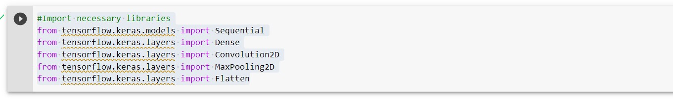

# #Image augmentation

from tensorflow.keras.preprocessing.image import ImageDataGenerator train_datagen = ImageDataGenerator(rescale=1./255,shear_range=0.2,zoom_range=0.2,horizontal_fl ip=True,vertical_flip=True)

test_datagen = ImageDataGenerator(rescale=1./255)



# #Dataset

x_train=train_datagen.flow_from_directory(r"E:\Flowers\Training",target_size=( 128,128),batch_size=32,class_mode="categorical") x_test=test_datagen.flow_from_directory(r"E:\Flowers\Testing",target_size=(128

,128),batch_size=32,class_mode="categorical")

x_train.class_indices

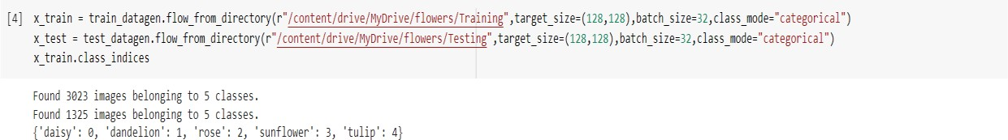

# #Add layers

model = Sequential()

**#Convolution layer** model.add(Convolution2D(32,(3,3),input_shape=(128,128,3),activation='relu')) **#Maxpooling layer**

model.add(MaxPooling2D(pool_size=(2,2)))

**#Flatten layer** model.add(Flatten()) **#Hidden layer**

model.add(Dense(units=300,kernel_initializer="random_uniform",activation="relu

"))

model.add(Dense(units=200,kernel_initializer="random_uniform",activation="relu "))

model.add(Dense(units=5,kernel_initializer="random_uniform",activation="softma x"))

model.summary()

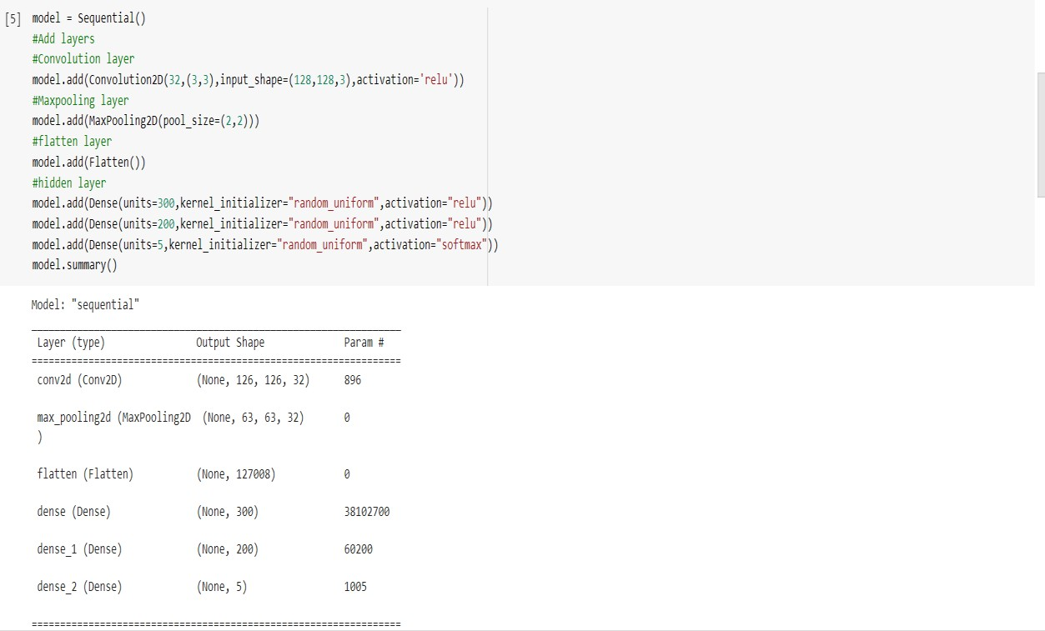

# #Compile the model

model.compile(loss="categorical_crossentropy",optimizer="adam",metrics=["accur acy"])

# #Fit the model

model.fit_generator(x_train,steps_per_epoch=75,epochs=15,validation_data=x_tes t,validation_steps=80)

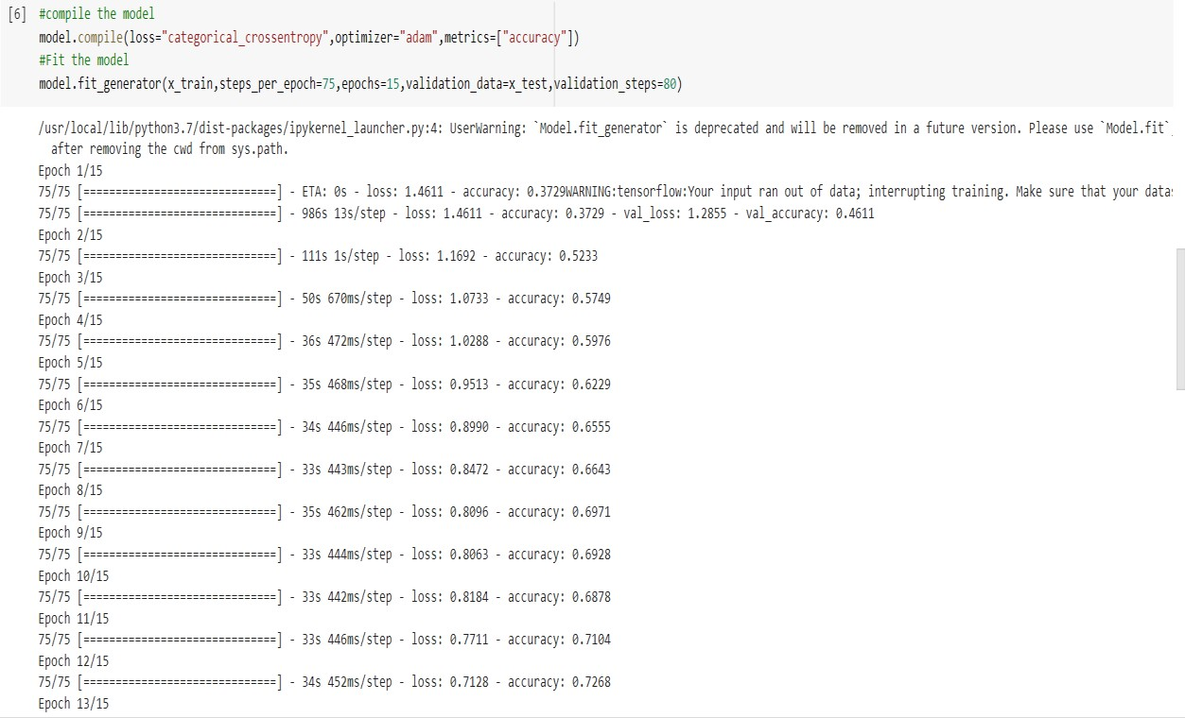

# #Save the model

model.save("flower.h5")



from tensorflow.keras.models import load_model from tensorflow.keras.preprocessing import image import numpy as np

model = load_model("Flower.h5")

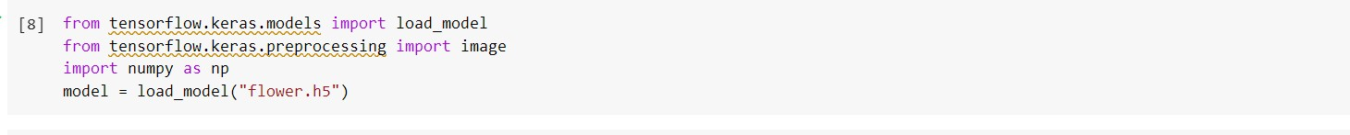

# #Test the model

img = image.load_img(r"C:\Users\hp\Downloads\rose.jpg",target_size=(128,128)) img

type(img)

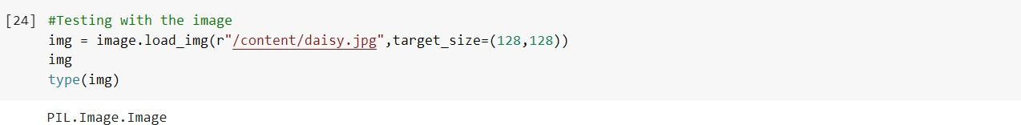

x = image.img_to_array(img) x

x.shape

x = np.expand_dims(x,axis=0) x.shape

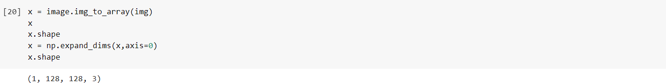

pred_prob = model.predict(x) pred_prob



class_name = ["daisy","dandelion","rose","sunfower","tulip"]



pred_id = pred_prob.argmax(axis=1)[0] pred_id

print("Predicted flower is",str(class_name[pred_id]))

